***Lesson 5***

**Column Aliases: -** we used to Renames a column heading

**Example 1**: select first_name as name from employees;

**Example 2**: select first_name "First Name" from employees;

***Lesson 6***

**Concatenation Operator: -**

* Links columns or character strings to other columns.
* It is represented by two vertical bars (||).
* Creates a resultant column that is a character expression.

**Example 1**: select last_name||job_id as "Employees" from employees;

**Example 2**: select last_name||' '||job_id as "Employees" from employees;

**Alternative Quote (q) Operator:**

* Specify your quotation mark delimiter.
* Select any delimiter.
* Increase readability and usability.

**Example**: select last_name||q'( job's id is: )'||job_id as "Employees" from employees;

**Duplicate Rows:** removes duplicates from the table.

**Example**: select distinct DEPARTMENT_ID from employees;

**Describe:** describe the created tables.

**Example**: desc employees;

***Lesson 7***

**Restricting & Sorting data:** using where to restrict or sort the data

**Example**: SELECT employee_id, last_name, job_id, department_id, salary, hire_date

FROM employees

WHERE hire_date = '17-feb-04';

**Comparison Operator:** =, >, >=, <, <=, <>, BETWEEN…...AND…., IN (SET, SET2), LIKE, IS NULL

**Logical Operator:**

* AND: Return true if both are true
* OR: Return true if either is true
* NOT: Return true if false

**Rules of AND & OR:** Oracle always take AND first so it’s better to use () to get what you need.

**Example:**  SELECT employee_id, last_name, job_id, department_id, salary, hire_date

from employees

where (job_id = 'SA_REF'

OR job_id = 'AD_PRES')

AND salary > 10000;

***Lesson 8***

**Order By:** It’s always in the last line of the code. We can us any order that is in the table with **ASC & DESC,** and we can use two orders, one DESC and one ASC.

**Example:** SELECT first_name, last_name, employee_id, hire_date

FROM employees

ORDER BY hire_date, first_name desc;

***Lesson 9***

**Substitution Variables:** We used to make an input pop-up for user to search about what he needs, and we can use **define Variables** to define the variables in the first of the code and make it usable.

**Example:** define col1 = salary

SELECT first_name, last_name, employee_id, hire_date, &col1

FROM employees

WHERE &col1 > 12000

ORDER BY &col1;

undefine col1

***Lesson 10***

**Single Row Functions:**

* Character
* Number
* Data
* Conversion
* General

**Character:**

* Case-Conversion Function
* Character-Manipulation Function

**Case-Conversion Function:**

* LOWER: Change the character from upper to lower letters
* UPPER: Change the character from lower to upper letters
* INITCAP: Change the first letter to the upper

**Example:** SELECT UPPER(first_name) "LAST NAME", LOWER(last_name) "first name", INITCAP(job_id) "Job id"

from employees;

***Lesson 11***

**Character-Manipulation Function:**

* **CONCAT**: it's not usable and it’s the same as Concatenation Operation || is more advanced.
  + SELECT first_name||last_name, CONCAT(first_name, last_name) FROM employees;
* **SUBSTR**: it’s used to select several letters from a word.
  + select first_name, last_name, job_id FROM employees WHERE SUBSTR(job_id,1,2) = 'SA';
* **LENGTH:** It’s used to know the number of the letters in the word.
  + SELECT first_name, last_name, LENGTH(first_name) FROM employees;
* **INSTR:** it’s used to know the position number in the word.
  + SELECT first_name, last_name, INSTR(first_name, 'n',1,2) FROM employees;
* **LPAD:** It’s used to add letters to the LEFT of the word.
  + SELECT first_name, last_name, LPAD(salary, LENGTH(SALARY)+1, '$') FROM employees;
* **RPAD:** It’s used to add letters to the RIGHT of the word.
  + SELECT first_name, last_name, RPAD(salary, LENGTH(SALARY)+1, '$') FROM employees;
* **REPLACE:** It’s used to REPLACE letters with other letters.
  + SELECT first_name, last_name, REPLACE(first_name, 'e', 'i') FROM employees;
* **TRIM:** It’s used to remove the beginning of the word and the end of it.
  + SELECT TRIM(' ' FROM ' Nader Mamdouh ') FROM dual;

***Lesson 12***

**Number Functions:**

* **ROUND:** Rounds value to a specified decimal.
  + Example: Select ROUND(63.323,2), ROUND(63.323,0), ROUND(63.323,-1), ROUND(63.323,-2), ROUND(446.323,-3) FROM dual;
* **TRUNC**: Truncates value to a specified decimal.
  + Example: Select TRUNC(63.326,2), TRUNC(63.326, 0), TRUNC(93.326,-2) FROM dual;
* **MOD**: Returns the remainder of the division.
  + Example: Select MOD(16, 2), MOD(17, 2) FROM dual;

***Lesson 13***

**Oracle DATE:** The Oracle Database stores dates in numbers function that we can use in ARITHMETIC ways,

* **format**: century, year, month, day, hours, minutes, and seconds.
* **The default** date display format is DD-MON-RR.
* **SYSDATE**: is a function that returns Date and Time from the Database server.
  + Example: SELECT SYSDATE FROM dual;
* **CURRENT_DATE**: is a function that returns Date and Time from the client.
  + Example: SELECT CURRENT_DATE FROM dual;

**Date-Manipulation Functions:**

* **MONTH_BETWEEN:** Number of months between two dates.
  + Example: SELECT first_name, hire_date, ROUND(MONTHS_BETWEEN(sysdate, hire_date )/12, 1) FROM employees;
* **ADD_MONTHS:** Add calendar months to date.
  + Example: SELECT first_name, hire_date, ADD_MONTHS(hire_date,1) FROM employees;
* **NEXT_DAY:** Next day of the date specified.
  + Example: SELECT first_name, sysdate, NEXT_DAY(SYSDATE, 'MON') FROM employees;
* **LAST_DAY:** Last day of the month of the date specified.
  + Example: SELECT first_name, hire_date, LAST_DAY(HIRE_DATE) FROM employees;
* **ROUND:** Round date.
  + Example: SELECT first_name, hire_date, ROUND(HIRE_DATE, 'MONTH'), ROUND(HIRE_DATE, 'YEAR') FROM employees;
* **TRUNC:** Truncate date.
  + Example: SELECT first_name, hire_date, TRUNC(HIRE_DATE, 'MONTH'), TRUNC(HIRE_DATE, 'YEAR') FROM employees;

***LESSON 14***

**Conversion Function:**

**Data Type Conversion: -**

* **Implicit data type conversion:** In expressions, the Oracle Server can automatically convert the following:
  + VARCHAR2 or CHAR to NUMBER or DATE
    - Example: SELECT last_name, employee_id FROM employees WHERE employee_id = '200';

**Explicit data type conversion:** this uses functions to change the data type from number or date to char or the opposite:

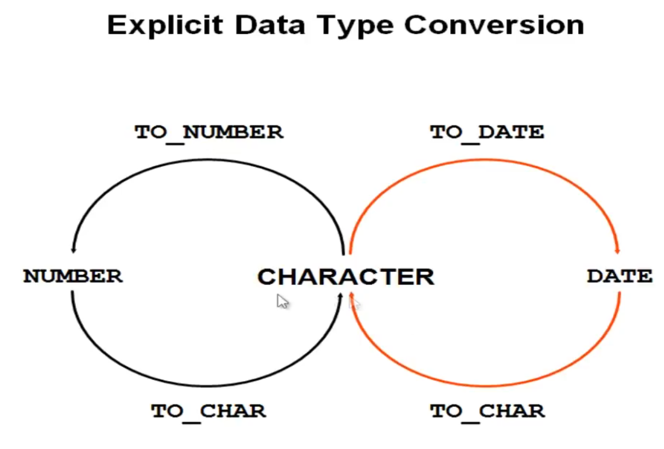

* **TO_CHAR:** Used to change date or number to char.
  + Example1: SELECT hire_date, TO_CHAR(hire_date, 'dd-mm-yyyy') FROM employees;

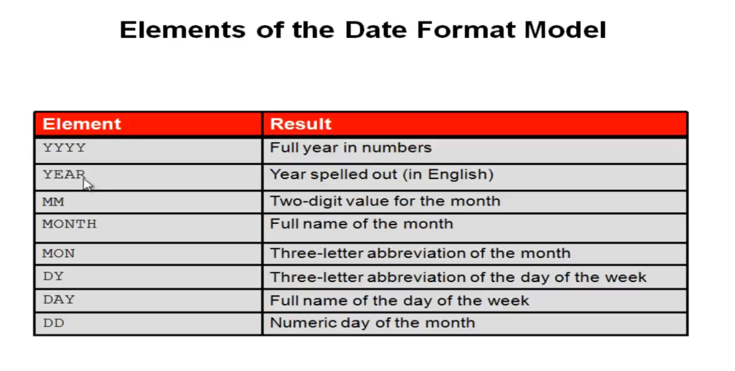

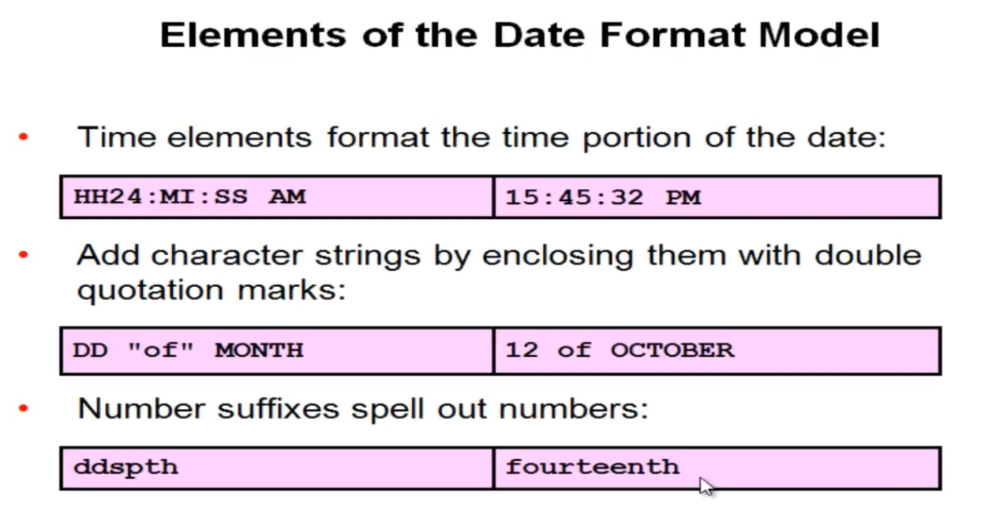

* + Example2: SELECT first_name, salary, TO_CHAR(salary, 'L999,999,999.00') FROM employees;

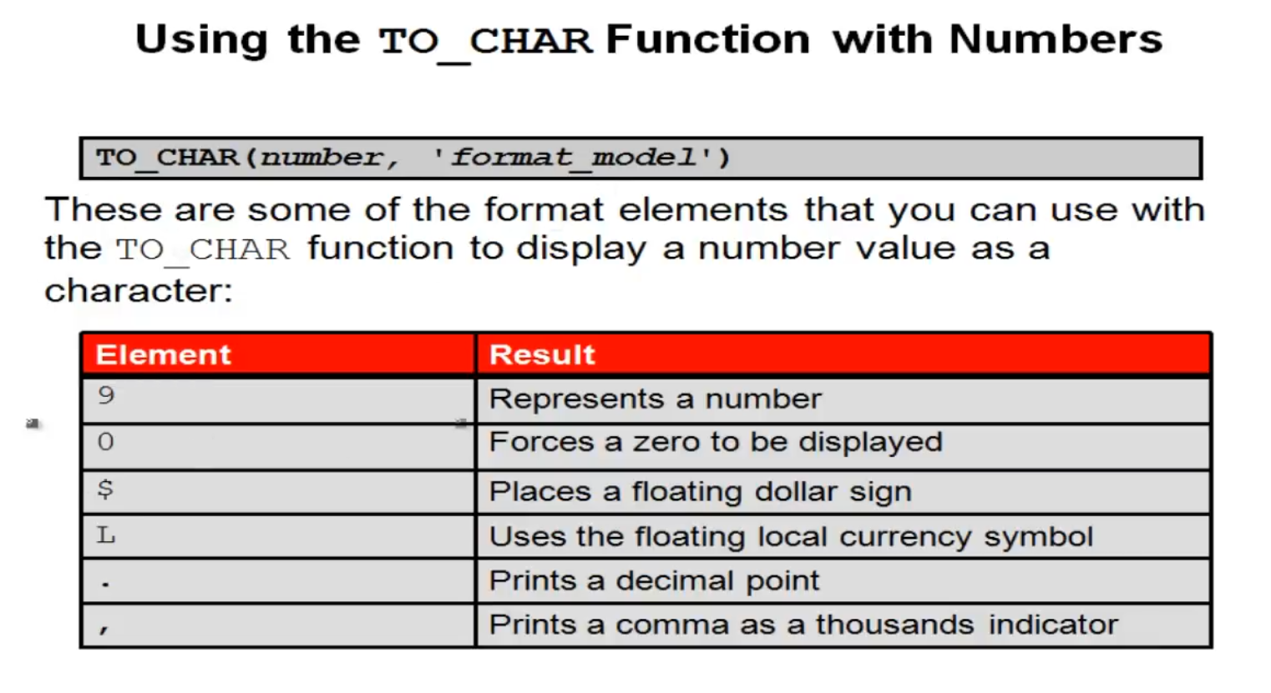

* **TO_DATE:** Convert a character string to a DATE format**.**
  + Example1: SELECT last_name, hire_date FROM employees WHERE hire_date <= TO_DATE('01/02/2007', 'dd-mm-yyyy');

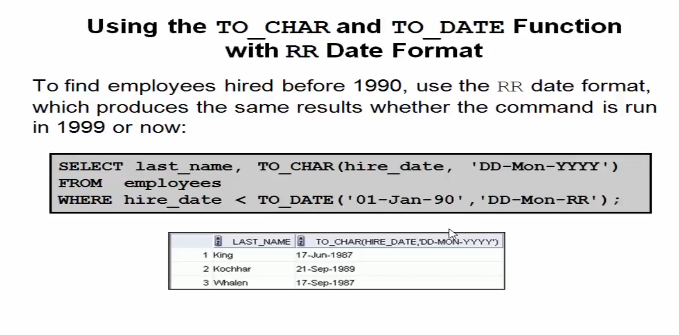

* **TO_NUMBER**: Convert a character string to a number format.
  + Example1: SELECT TO_NUMBER('01112008903', '99999999999999') FROM dual;

***LESSON 15***

**Nesting Functions:**

* Single-Row Function can be nested to any level.
* Nesting Functions are evaluated from the deepest level to the least deep level.
  + Example: SELECT first_name, UPPER(CONCAT(SUBSTR(first_name, 1, 3), '_MI')) FROM employees;

**General Functions:** The following functions work with any data type and pertain to using null.

* **NVL**: Changing NULL to numbers to use it in mathematics.
  + Example: SELECT first_name, salary, commission_pct, NVL(commission_pct, 1) FROM employees;
* **NVL2**: This means if null, give a result and we can make the result be char.
  + Example: SELECT first_name, salary, commission_pct, nvl2(commission_pct, salary*1.1, 0) FROM employees;
* **NULLIF**: Compare between 2 values and if == give you null and if \= result value 1.
  + Example: SELECT length(first_name), length(last_name), NULLIF(length(first_name), length(last_name)) FROM employees;
* **COALESCE**: search between values and when find the first not null value get it.
  + Example: SELECT COALESCE(NULL, NULL, NULL, 1,NULL) FROM dual;

**Conditional Expressions:**

* **CASE:**
  + Example: SELECT last_name, job_id , salary,

CASE job_id WHEN 'PU_MAN' THEN 1.15 * salary

WHEN 'SH_CLERK' THEN 1.3 * salary

WHEN 'AC_ACCOUNT' THEN 1.4 * salary

WHEN 'FI_ACCOUNT' THEN 1.51 * salary

ELSE SALARY * 1.1 END "Annual Salary increase" FROM employees;

* **DECODE:** 
  + Example: last_name, job_id , salary,

DECODE( job_id , 'PU_MAN' , 1.15 * salary

, 'SH_CLERK' , 1.3 * salary

, 'AC_ACCOUNT' , 1.4 * salary

, 'FI_ACCOUNT' , 1.51 * salary

, SALARY * 1.1) "Annual Salary increase" FROM employees;

***LESSON 16***

**Group Functions:** Used in a group of rows to get the Output and we can use null and distinct.

* **AVG:** Get the Average for a group of numbers.
  + Example: SELECT AVG(salary) "Average" FROM employees;
* **COUNT:** Count the number of rows in columns.
  + Example: SELECT COUNT(distinct salary) "SUM" FROM employees;
* **MAX:** Get the higher number the newest date or the last letter.
  + Example: SELECT MAX(salary), MAX(hire_date), MAX(first_name) "SUM" FROM employees;
* **MIN:** Get the smallest number the oldest date or the first letter.
  + Example: SELECT MIN(salary), MIN(hire_date), MIN(first_name) "SUM" FROM employees;
* **SUM:** get the sum for a group of numbers.
  + Example: SELECT SUM(salary) "SUM" FROM employees;
* **STDDEV**
  + Example:
* **VRINANCE**
  + Example:

***LESSON 17***

**BROUP BY:** You can divide rows in a table into smaller groups by using the GROUB BY clause.

* Example: SELECT department_id, job_id, commission_pct, count(*) FROM employees

WHERE department_id = 50

GROUP BY department_id, job_id, commission_pct ORDERBY 2;

**HAVING:** we used likes order by but with GROUP BY.

* Example: SELECT department_id, job_id, commission_pct, count(*) FROM employees

WHERE department_id = 50

GROUP BY department_id, job_id, commission_pct

HAVING count(*) > 5 ORDER BY 2;

**NESTING GROUP FUNCTIONS:** we can use nesting with GROUP FUNCTIONS

* Example: SELECT MAX(avg(salary)) FROM employees GROUP BY salary;

***LESSON 18***

**Types Of Joins**: Joins that are compliant with the SQL: 1999 standard include the following:

* **NATRUAL JOINS:** Is 1 of the Joins types
  + **NATRUAL JOINS**: We Used to join 2 tables with the PK and FK its have to be the same data type
    - Example: SELECT department_id, department_name, location_id, city FROM departments d NATURAL JOIN locations;
  + **USING**: we used it when we needed to join 2 tables with different data types.
    - Example: SELECT department_id, department_name, location_id, city FROM departments d JOIN locations USING (location_id);
  + **ON**: We used when we needed to join 2 tables with different names.
    - Example: SELECT department_id, department_name location_id, city FROM departments d JOIN locations l ON (d.location_id = l.location_id);
  + **More than 2 tables**: we can use more than 2 tables.
    - Example: SELECT e.last_name, d.department_id, department_name, l.location_id, city FROM departments d JOIN locations l ON (d.location_id = l.location_id) JOIN employees e ON d.manager_id = e.employee_id;
  + **WHERE & AND & OR:** we can use where, and, or in different table.
    - **Example:** SELECT e.last_name, d.department_id, department_name, l.location_id, city FROM departments d JOIN locations l ON (d.location_id = l.location_id) JOIN employees e ON d.manager_id = e.employee_id WHERE d.department_id = 70 OR d.department_name = 'IT' AND e.last_name = 'Hunold';
  + **SELF JOIN:** You can make 2 tables and join each other from the table itself.
    - **Example:** SELECT a.employee_id worker, a.last_name, b.employee_id manager, b.last_name FROM employees a JOIN employees b ON a.manager_id = b.employee_id;
  + **None EquiJoins:** Retrieving Records with NoneEquiJoins.
    - **Example:** SELECT e.last_name, e.salary, j.grade_level FROM employees e JOIN job_grades j ON e.salary BETWEEN j.lowest_sal AND j.highest_sal;

***LESSON 19***

* **OUTER JOIN:**
  + **LEFT OUTER JOIN:** shows the nulls value of the left columns.
    - **Example:** SELECT a.employee_id worker, a.last_name, b.employee_id manager, b.last_name FROM employees a LEFT OUTER JOIN employees b ON a.manager_id = b.employee_id;

* + **RIGHT OUTER JOIN:** shows the nulls value of the right columns.
    - **Example:** SELECT e.last_name, d.department_id, d.department_name FROM employees e RIGHT OUTER JOIN departments d ON (e.department_id = d.department_id);
  + **FULL OUTER JOIN:** shows the nulls value of ALL columns.
    - **Example:** SELECT e.last_name, d.department_id, d.department_name FROM employees e FULL OUTER JOIN departments d ON (e.department_id = d.department_id);

* **Cartesian Product:** All rows in the first table are joined to all rows in the second table, to avoid a Cartesian product, always include a valid join condition.
  + **CROSS JOIN:** 
    - SELECT last_name, department_name FROM employees CROSS JOIN departments;

***LESSON 20***

**Subquery:** We can used in make another select statement to get a specific output to used in the main statement.

* we use it in ().
* Its better to put it in the right the code to easy read.
* We use Single-row operators with Single-row subquery and the Multiple-row operators with Multiple-row subquery

**Example**: SELECT last_name, salary FROM employees WHERE salary > (SELECT salary FROM employees WHERE last_name = 'Abel');

**Single-row subqueries**: Return only one row & use single- row comparison operators.

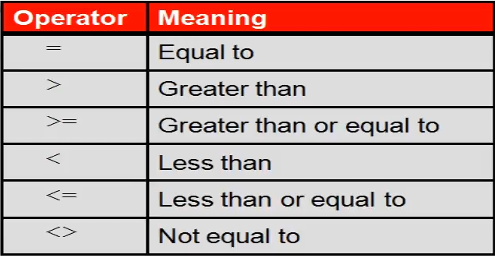

**Example:** SELECT last_name, salary FROM employees WHERE salary > (SELECT salary FROM employees WHERE last_name = 'Abel') AND salary < (SELECT salary FROM employees WHERE last_name = 'King' and salary > 10000);

* **Group Functions in a Subquery:** we can use group functions in and with subqueries.
  + **Example:** SELECT last_name, salary FROM employees WHERE salary > (SELECT AVG(salary) "Average" FROM employees) AND salary < (SELECT MAX(salary) "MAX" FROM employees);
* **HAVING clause with Subquery:**
  + **Example:** SELECT department_id, min(salary) FROM employees GROUP BY department_id HAVING min(salary) > (SELECT min(salary) "Minimum" FROM employees WHERE department_id =50);

***LESSON 21***

**Multiple-row subqueries:** when we need to use multiple row to used.

* **IN :** SELECT employee_id, last_name, job_id, salary FROM employees WHERE salary IN OR = ANY (SELECT salary FROM employees WHERE job_id = 'IT_PROG') AND job_id <> 'IT_PROG';
* **ANY :** SELECT employee_id, last_name, job_id, salary FROM employees WHERE salary < ANY (SELECT salary FROM employees WHERE job_id = 'IT_PROG') AND job_id <> 'IT_PROG';
* **ALL :** SELECT employee_id, last_name, job_id, salary FROM employees WHERE salary < ALL (SELECT salary FROM employees WHERE job_id = 'IT_PROG') AND job_id <> 'IT_PROG';
* **NULL VALUES :** will always get 0 rows if we have null;
  + **Example:** SELECT emp.last_name FROM employees emp WHERE emp.employee_id NOT IN (SELECT mgr.manager_id FROM employees mgr);

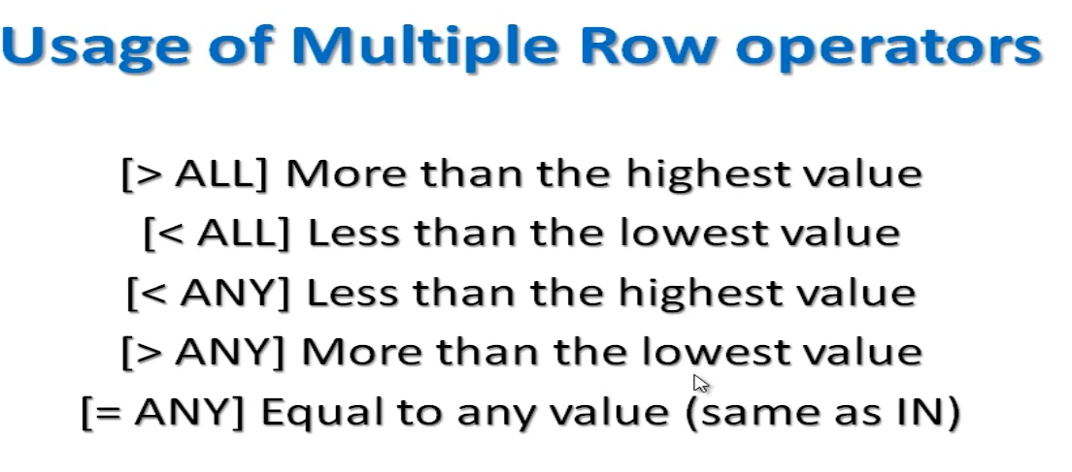

***LESSON 22***

**Set Operators:** When we need to get the data from 2 tables or the different from this data.

* **UNION ALL:** get the all data from the 2 tables with the duplicate
  + **Example:** SELECT employee_id, job_id FROM employees WHERE employee_id = 200 UNION ALL SELECT employee_id, job_id FROM job_history WHERE employee_id = 200;

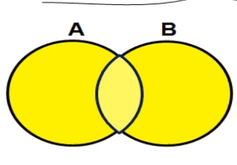

* **UNION:** get the all data from the 2 tables without the duplicate
  + **Example:** SELECT employee_id, job_id FROM employees WHERE employee_id = 200 UNION SELECT employee_id, job_id FROM job_history WHERE employee_id = 200;

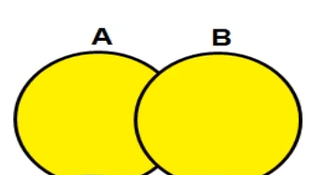

* **INTERSECT:** Get the duplicated area from the 2 tables
  + **Example:** SELECT employee_id, job_id FROM employees WHERE employee_id = 200 INTERSECT SELECT employee_id, job_id FROM job_history WHERE employee_id = 200;



* **MINUS:** Get the data from the first table that isn’t in the second table” we can say from the example that we can’t the data that didn’t changed”.
  + **Example:** SELECT employee_id, job_id FROM employees MINUS SELECT employee_id, job_id FROM job_history;

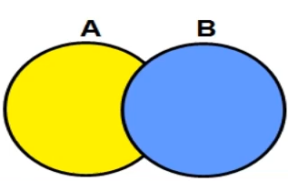

* **MATCHING:** that is a rule that we can’t get more info from the first table without matching the output from the second table.
  + **Example:** SELECT employee_id, job_id, salary, 'current' FROM employees UNION SELECT employee_id, job_id, 0, to_char(end_date, 'dd/mm/yyyy') FROM job_history;

***LESSON 23***

**DML** : Data Manipulation Language.

* A DML Statement is executed when you:
  + Add new rows to a table.
  + Modify existing rows in a table.
  + Remove existing rows from a table.
* A transaction consists of a collection of DML statements that from a logical unit of work.

Adding New row to a Table:

* **INSERT Statement Syntax:** Add new row to a table by using INSERT statement 1 row at a time.
  + **Example:** INSERT INTO departments(department_id, department_name, manager_id, location_id) VALUES (300, 'IT_NADER', 200, 1700);
* **INSERT rows with null values:** we have 2 methods.
  + **Implicit method:** omit the column from the column list.
    - **Example:** INSERT INTO departments(department_id, department_name) VALUES (301, 'IT_NADER');
  + **Explicit method:** Specify the NULL keywords in the VALUES.
    - **Example:** INSERT INTO departments(department_id, department_name, manager_id, location_id) VALUES (302, 'IT_NADER', NULL, NULL);
* **INSERT Special and Specific Values:** The SYSDATE function records the current date and time.
  + **Example 1:** INSERT INTO employees(employee_id, last_name, email, hire_date, salary, commission_pct, job_id) VALUES (300, 'Nader', 'nader', SYSDATE, 2000, 0.2, 'IT_PROG');
  + **Example 2:** INSERT INTO employees(employee_id, last_name, email, hire_date, salary, commission_pct, job_id) VALUES (301, 'Mamdouh', 'nader1', to_date('31/10/2024', 'dd/mm/yyyy'), 2001, 0.2, 'IT_PROG');
* **Creating a Script:** Use & substitution in a SQL statement to prompt for values (& is a placeholder for the variable value.).
  + **Example 1:** INSERT INTO departments(department_id, department_name) VALUES (&D_ID, '&D_Name');
* **Copying Rows from Another Table:** Write your INSERT statement with a subquery( you have to match the numbers of columns in the INSERT clause in the subquery).
  + **Example 1:** INSERT INTO NEW_EMPLOYEES(id, first_name, last_name, salary, commission_pct) SELECT employee_id, first_name, last_name, salary, commission_pct FROM employees WHERE job_id = 'IT_PROG';

***LESSON 24***

Thats code to create a copy of Employees table:

CREATE TABLE COPY_EMPLOYEES AS SELECT * FROM EMPLOYEES;

**UPDATE:** we use it to update data in table and we have to use WHERE because if we didn’t that will update the entire table.

* **Example 1:** update copy_employees set department_id = 90;
  + in example 1 we use it without WHERE and the entire table updated the department_id to 90.
* **Example 2:** update copy_employees set department_id = 90 WHERE employee_id = 113;

**UPDATE with subquery:** We can use subquery to update row.

* **Example:** update copy_employees set salary = (select salary from employees where employee_id = 206), department_id = (select department_id from employees where employee_id = 206) WHERE employee_id = 113;

**And we can use null.**

* **Example:** update copy_employees set salary = null WHERE employee_id = 113;

***LESSON 25***

Note: CREATE TABLE employees_copy AS SELECT * from employees

**Removing a row from a table:** We can delete a row from a table with the syntax DELETE.

* **Example:** DELETE employees_copy WHERE employee_id = 105;

**We can use Subquery with delete:**

* **Example:** DELETE employees_copy WHERE employee_id = (SELECT employee_id FROM EMPLOYEES WHERE SALARY > 20000);

When we remove WHERE we will delete all the table data and if we did we can use ROLLBACK to fix it.

**Example:** DELETE employees_copy; ROLLBACK;

**TRUNCATE:** this remove the all table or make a delete but we cant comeback after DDL langauge.

**Example:** TRUNCATE employees_copy

***LESSON 26***

**Database Transactions:** Start and End

* Begin when the DML SQL Statement is executed.
* End with one of the following events:
* A COMMIT or ROLLBACK Statement is issued.
* A DDL or DCL Statement executes (Automatic commit).
* The User exit SQL Developer or SQL plus.
* The system crashes.

**COMMIT and ROLLBACK:** its like a savepoints and we can use it to be sure and before make the changes.

**ROLLBACK:** its make you back from the begining and remove the all changes you did it

* **Example:** DELETE employees_copy; ROLLBACK;

**COMMIT:** its commit all changes and save the data.

* **Example:** DELETE employees_copy; COMMIT;

**SAVEPOINT:** its saveing changes and use it to back to savepoint we choose.

* **Example:** UPDATE employees_copy SET SALARY = 10000 WHERE employee_id = 103;

SAVEPOINT a;

UPDATE employees_copy SET SALARY = 10000 WHERE employee_id = 104;

SAVEPOINT b;

UPDATE employees_copy SET SALARY = 10000 WHERE employee_id = 105;

DELETE employees_copy;

ROLLBACK TO SAVEPOINT b;

**FOR UPDATE:** use to lock the other users from select the rows you use and we can make from many tables so we can use joins.

* **Example:** SELECT e.employee_id, e.salary, e.commission_pct FROM EMPLOYEES e JOIN departments d USING (department_id)

WHERE job_id = 'ST_CLERK' AND location_id = 1500

FOR UPDATE

ORDER BY e.employee_id;

***LESSON 27***

Notes: Referencing Another User’s Tables: We can use it if we make a user for performance and user for claim’s and user for management’s we can used to connect the tables with each other.

**Database Objects:**

* **Table:** Basic Unit of storage, composed with rows
* **View:** Its show you data from tables to edit and represent.
* **Sequence:** Generates Numeric values.
* **Index:** Improves the performance of some queries.
* **Synonym:** we can use to give sample names to objects.

**Naming Rules:**

* Must to begin with a latter.
* Must be 1-30 char long.
* Must be contain only A-Z, a-z, 0-9, _, $, and #.
* Must not duplicate the object name in the same user.
* Most not be an Oracle server words like: SELECT, FROM, ……etc.

**CREATE TABLE Statement:**

* **Example:** CREATE TABLE DEMP(d_id number(9), first_name varchar2(30), last_name varchar2(30), create_date date DEFAULT sysdate);

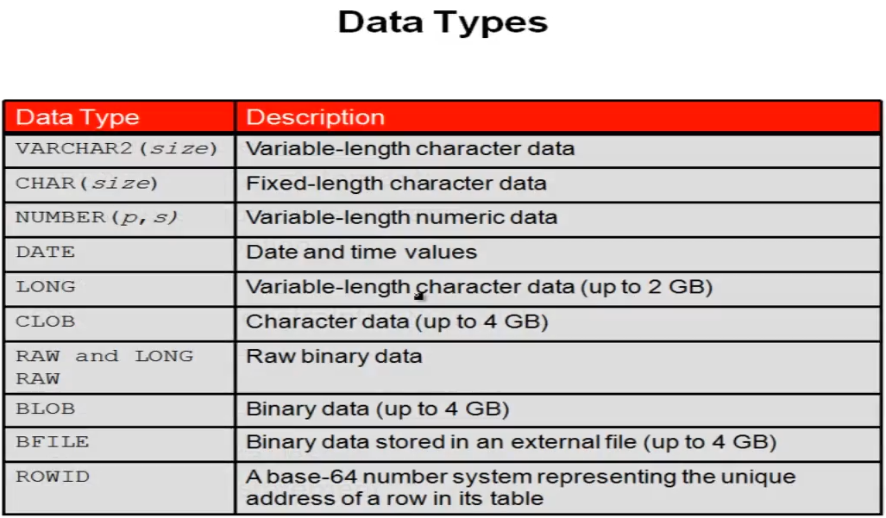

***LESSON 28***

**Constraints:** Is to make rules make less miss entering wrong data.

* **NOT NULL:** Can’t make the table null or empty.
* **UNIQUE:** Is a unique data can be duplicated.
* **CHECK:** Check if the data entered is required.
* **PRIMARY KEY:** It’s a unique key generated and cant be duplicated.
* **FOREIGN KEY:** It's make reference to PK or another table and can be duplicated and can be null.
  + **Example:** CREATE TABLE EMP(

emp_id number(10),

emp_name varchar2(30) NOT NULL,

salary NUMBER(8,2),

email varchar2(50),

dept_id number(10),

CONSTRAINT emp_pk PRIMARY KEY(emp_id),

CONSTRAINT sa_ck CHECK(salary > 1000) ,

CONSTRAINT em_un UNIQUE(email),

CONSTRAINT dept_fk FOREIGN KEY(dept_id) REFERENCES DEPARTMENTS(DEPARTMENT_ID));

***LESSON 29***

**Create Table Using Subquery:** We can copy a table with subquery from another table.

* **Example:** CREATE TABLE EMP100 AS (SELECT * FROM employees WHERE department_id = 100);

***LESSON 30***

**Alter Table: We used to modify or change or add new column to the exist table.**

* **ADD:** We can add new column to the table.
  + **Example:** ALTER TABLE emp ADD (first_name VARCHAR2(30), last_name VARCHAR2(30));
* **RENAME:** We can rename the column in the table.
  + **Example:** ALTER TABLE emp RENAME COLUMN emp_name TO full_name;
* **MODIFY:** We can modify the data in the column we already created.
  + **Example:** ALTER TABLE emp MODIFY comm NUMBER(10,2);
* **DROP:** We can delete column from the table.
  + **Example:** ALTER TABLE emp DROP COLUMN comm;
* **RENAME(Table):** We can rename the table with it.
  + **Example:** ALTER TABLE emp RENAME to NEW_EMPLOYEES;

***LESSON 31***

**View: We can used to create new view from tables to used to show it to other user’s or be shortcut to our query.**

* **CREATE VIEW:** We can create the view with it.
* **Example:** CREATE VIEW emp_dit AS SELECT e.first_name, e.salary, d.department_name, l.city, l.postal_code FROM EMPLOYEES e, DEPARTMENTS d, LOCATIONS l WHERE e.department_id = d.department_id and d.location_id = l.location_id;
* **REPLACE:** modify the view or change it.
  + **Example:** CREATE or REPLACE VIEW emp_dit AS SELECT e.first_name, e.salary, d.department_name, l.city, l.street_address FROM EMPLOYEES e, DEPARTMENTS d, LOCATIONS l WHERE e.department_id = d.department_id and d.location_id = l.location_id;
* **DROP:** Delete the view.
  + **Example:** DROP VIEW emp_dit;

***LESSON 32***

**SEQUENCE: Is to create a id or number generator for your next insert values.**

* **CREATE SEQUENCE**: Is to create a new sequence.
  + **Example**: **CREATE SEQUENCE** seq START WITH 5 INCREMENT BY 1 NOCACHE;
* **START WITH:** this is the number we should start with we set it as the the tables stops or begin.
  + **Example**: CREATE SEQUENCE seq **START WITH 5** INCREMENT BY 1 NOCACHE;
* **INCREMENT BY:** Here we set the increment of the seq value in every insert to the table
  + **Example**: CREATE SEQUENCE seq START WITH 5 **INCREMENT BY 1** NOCACHE;
* **MINVALUE:** We set the min value we start from it we used because if the last id in the table is 5 so we need to start from 5 and if we removed from the query will use the start as minvalue.
  + **Example**: CREATE SEQUENCE seq START WITH 5 INCREMENT BY 1 **MINVALUE 5** NOCACHE;
* **MAXVALUE:** We use it to set the end of the seq so if the seq get to the value 900 will end there.
  + **Example**: CREATE SEQUENCE seq START WITH 5 INCREMENT BY 1 **MAXVALUE 900** NOCACHE;
* **CACHE & NOCACHE:** Cache is to store amount of values in the memory for fast insert but if the app crash the seq will start from last value we put it in the cache.
  + **Example**: CREATE SEQUENCE seq START WITH 5 INCREMENT BY 1 **NOCACHE OR CACHE 30**;
* **NEXTVAL:** Here we used to when we insert new value with the sequence.
  + **Example**: INSERT INTO regions values (seq.nextval, 'EGYPT');
* **DROP:** Used to delete the sequence.
  + **Example**: DROP SEQUENCE seq;

***LESSON 33***

**INDEX: Is used to improve the performance to the query so it can used to make the search for the data faster and we should use just for the search column or something we use to join between tables.**

* **CREATE INDEX:** Its easy to create index and we cant modify just delete and created again.
  + **Example:** CREATE INDEX EMP_LAST_NAME ON EMPLOYEES(LAST_NAME);
* **DROP INDEX:** Use it to delete the indexs.
  + **Example:** DROP INDEX EMP_LAST_NAME;

***LESSON 34***

**SYNONYM: Is used to create alternative names to objects, and we can used if we want to write a table from other users.**

* **CREATE SYNONYM:** used to create the new syn.
  + **Example:** CREATE SYNONYM x FOR scott.emp;
* **DROP SYNONYM:** Is used to delete the syn.
  + **Example:** DROP SYNONYM x;